Photo-Controllable Catalysis and Chiral Monosaccharide Recognition Induced by Cyclodextrin Derivatives
Lei Chen,^{[a]} Yong Chen^{[a]} ,Yi Zhang^{[a]} and Yu Liu*^{[a]}
Dedicated to the 100th anniversary of Chemistry at Nankai University

[a] L. Chen, Dr. Y. Chen, Yi Zhang, Prof. Dr. Y. Liu
College of Chemistry, State Key Laboratory of Elemento-Organic Chemistry, Nankai University
Tianjin 300071 (P. R. China)
E-mail: yuliu@nankai.edu.cn

ABSTRACT: A supramolecular catalytic system was constructed by polycationic α-cyclodextrin (6-Iz-α-CD), gold nanoparticles (AuNP) based on supramolecular assembly strategy. The cavity of cyclodextrin is the channel which the substrate molecules contact with the catalytic center. Introduction of the azobenzene-modified diphenylalanine (Azo-FF) guest molecule allowed for photo-control of the catalytic activity precisely owing to its sensitive response to irradiation. Importantly, as unique glucose oxidase, the AuNP@6-Iz-α-CD realizes unprecedented chiral recognition catalysis for chiral monosaccharides. In combination with 3, 3, 5, 5-tetramethylbenzidine (TMB) color reaction, the AuNP@6-Iz-α-CD exhibits the ability to recognize the chirality of various monosaccharides.
Intelligent supramolecular assemblies are a hot topic of re-search owing to their potential applications for nanomedicine,^{[1]} nanomaterials,^{[2]} catalysis,^{[3]} and chiral molecular recognition.^{[4]} Considerable effort has been devoted to preparing intelligent supramolecular materials that respond to external stimuli such as enzymes,^{[5]} pH,^{[6]} and light.^{[7]} Among these stimuli, light is unique in that it can be delivered instantaneously to the responsive unit without hindrance by steric constraints or solvent viscosity.^{[8]} Many light-responsive compounds have been reported.^{[9]} Azobenzene derivatives are considered to be ideal triggers because their affinity for the cavities of cyclodextrins changes markedly upon irradiation, a property that has promopted research on the use of light to regulate the functional properties of supramolecular assemblies.^{[10]} For instance, we recently reported paclitaxel-modified β-cyclodextrin and arylazopyrazole assemblies that can be used for photo-control of microtubule aggregation in cells via a specific interaction between paclitaxel and microtubules and reversible binding between the arylazopyrazoles and β-cyclodextrin.^{[11]}
Gold nanoparticles (AuNP) are widely recognized as promising building blocks for intelligent supramolecular assemblies because their optical and catalytic properties depend on their aggregation state.^{[3b], [12]} One way to dynamically regulate their aggregation state is to use host–guest interactions. The usual method for accomplishing such regulation is to covalently attach host molecules directly to the AuNP surface and then add an appropriate guest molecule that acts as a cross-linking agent to promote AuNP aggregation.^{[13]} However, light-controlled regulation of the aggregation state and catalytic activity of AuNP in supramolecular systems remains relatively unexplored. In addition, the use of AuNP for selective catalysis has not been explored. Almost all host molecules have the ability to distinguish substrates, such as chiral cavities in cyclodextrins for enantiomers recognition. Thus, to develop AuNP for selective catalysis, we undertook to incorporate them into supramolecular assemblies held together by non-covalent interactions. Herein, we report the development of catalytic supramolecular assemblies held together by electrostatic interactions between AuNP and the polycationic cyclodextrin hexakis-(6-iodo-6-deoxy)-α-cyclodextrin (6-Iz-α-CD).^{[14]} An optically responsive azobenzene-modified diphenylalanine (Azo-FF) guest molecule was used to regulate the catalytic activity of the AuNP@6-Iz-α-CD through triggering a reversible morphological transition upon irradiation (Scheme 1). Importantly, the recognition of chiral molecules by 6-Iz-α-CD cavity can realize the selective catalytic oxidation of glucose with different configurations.^{[15]} Based on the chiral recognition catalysis oxidation ability of the AuNP@6-Iz-α-CD for chiral monosaccharide, combined with the color reaction of 3, 3, 5, 5-tetramethylbenzidine (TMB), provides an unprecedented conveniently way for colorimetric recognition of chiral monosaccharide.

Scheme 1. Photo-control of the catalytic activity of AuNP@6-Iz-α-CD assemblies and chiral recognition catalytic process.

The AuNP were prepared by a sodium citrate reduction method,^{[15]} and their particle size was verified by transmission electron microscopy (TEM) (average size = 17 nm, Figure S1a). The surface of the AuNP was covered with citrate groups and the potential of AuNP is -64mV (Figure S1b) and the 6-Iz-α-CD host molecules were synthesized by previously reported method (Scheme S1, Figure S2),^{[16]} To verify that mixing the AuNP and 6-Iz-α-CD resulted in coverage of the AuNP by 6-Iz-α-CD, we performed UV–vis spectroscopy and zeta potential measurements. In AuNP aqueous solution, the increase of 6-Iz-α-CD concentration results in surface potential changes from negative potential to positive potential and accompanied by the blue shift and then red shift of the surface plasmon resonance (SPR) absorption band,(Figure 1a, b) which indicated the AuNP experienced the process of dispersion in aqueous solution, aggregation and redispersion (Figure S3). ^{[17]} By monitoring the change of the absorption value of nanoparticles at 525 nm, it is determined that the uniform dispersion of AuNP@6-Iz-α-CD can be formed when the concentration of AuNP is 7.96×10⁻⁴g/L and the concentration of 6-Iz-α-CD is 4×10⁻⁵M (Figure S3a). The dynamic light scattering (DLS) test confirmed that the particle size of the assembly was in accordance with the theoretical value (theoretical value 18.57nm, Figure 1c, Scheme S2). Moreover, Fourier transform IR spectroscopy showed that the peak for the stretching vibration of the methylimidazole moiety of 6-Iz-α-CD (1341 cm⁻¹) was clearly weaker in the spectrum of AuNP@6-Iz-α-CD, which confirmed the presence of electrostatic interactions between 6-Iz-α-CD and the AuNP (Figure 1d). In order to further confirm the number of 6-Iz-α-CD on the AuNP surface, the thermogravimetric analysis was carried out on the AuNP@6-Iz-α-CD. It can be calculated that there are 2606 6-Iz-α-CD per AuNP by thermogravimetry data and formula calculation (Figure S4).
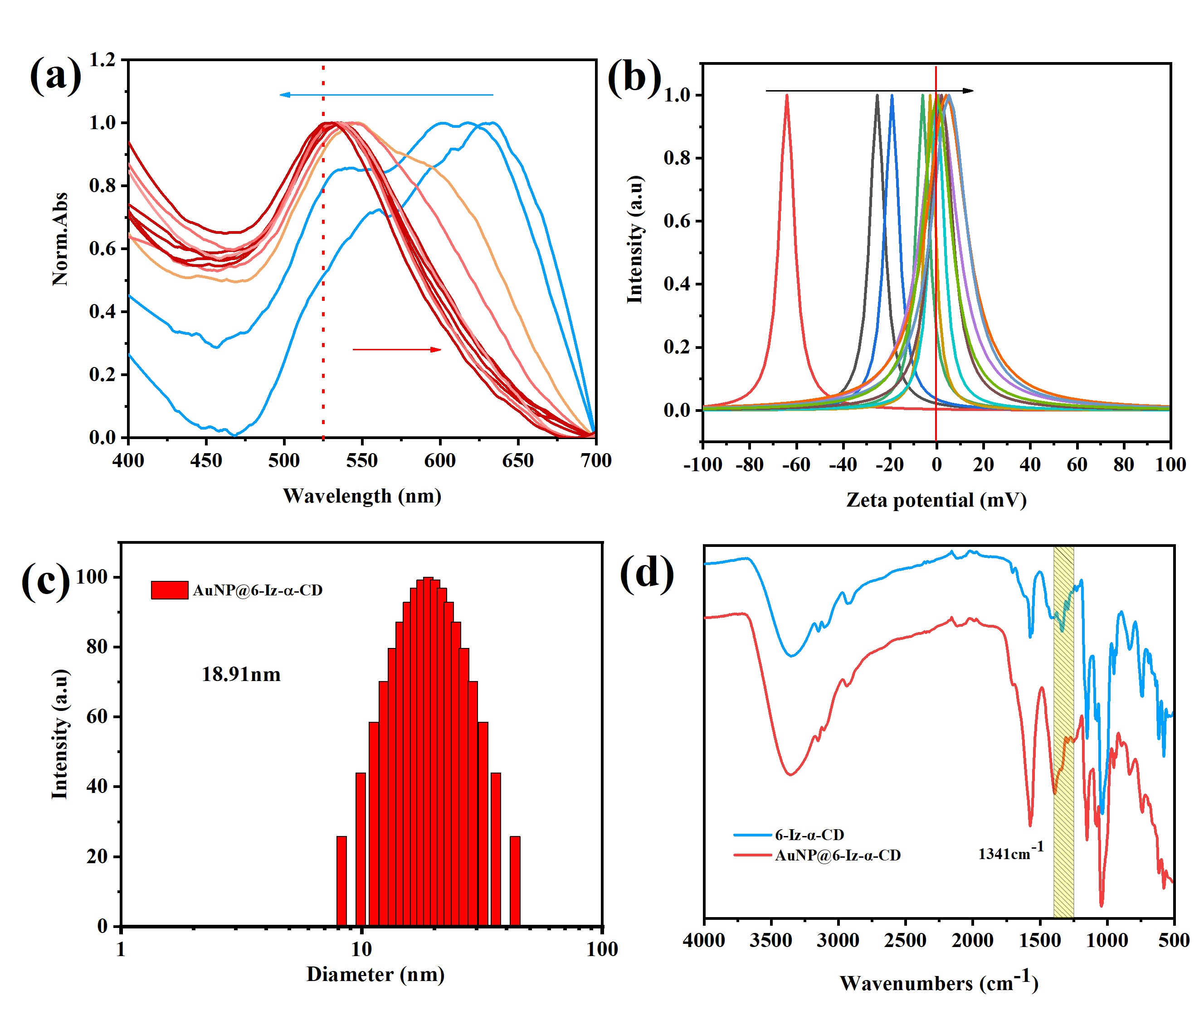
Figure 1. (a) SPR of AuNP after addition of 6-Iz-α-CD at various concentrations. (b) Zeta potentials of AuNP at various 6-Iz-α-CD concentrations ([Au] = 7.96×10⁻⁴g/L, [6-Iz-α-CD] = 0M~1.8×10⁻⁴M). (c) DLS analysis of AuNP@6-Iz-α-CD in aqueous solution (d) Fourier transform IR spectra of 6-Iz-α-CD and AuNP@6-Iz-α-CD.
The reduction of 4-nitrophenol (4-NP) with NaBH₄ at 25 ℃ was used as a model reaction to evaluate the catalytic activity of AuNP@6-Iz-α-CD and the reaction process was monitored by UV-vis spectroscopy.^{[18]} Firstly, AuNP exhibit high catalytic activity and the reaction was pseudo first order with respect to the absorbance (Figure 2a, Figure S5, K_{app}=3.97×10⁻³s⁻¹). Surprisingly, the catalytic process of AuNP@6-Iz-α-CD seems to be different from the above kinetic reaction process (Figure 2b). Hence, the circular dichroism spectroscopy was used to monitor the catalytic reaction process of AuNP@6-Iz-α-CD, it was found that the reaction process of 4-NP was carried out in the cavity of α-cyclodextrin (Figure S6). The catalytic reaction of the substrate in the cyclodextrin cavity has aroused our attempts to control the activity of the catalyst. Hence, using previously described methods,^{[10b]} we synthesized azobenzene guest molecules Azo-FF, for controlling the activity of the catalytic assemblies (Figures S7, 8, 9). Indeed, with the increase concentration of Azo-FF in the catalytic system, the 4-NP reduction model verified that the catalytic activity of the assembly decreased significantly (Figure 2c, Figure S10, 11). However, the addition of at least two equivalents Azo-FF was required to make the catalytic system dormant. Therefore, the assemble model between Azo-FF and AuNP@6-Iz-α-CD were study in detail. As shown in Figure 2d, the blue shift of UV absorption peak at 325 nm of azobenzene group and strong circular dichroism signal indicate that azobenzene group enters into the cyclodextrin cavity through host-guest interaction (Figure S12) ^{[19]}. Interestingly, the SPR absorption band belonging to AuNP gradually disappeared with the addition of Azo-FF, which indicated the formation of the assembly is accompanied by the detachment of AuNP from the solvent system. Combined with TEM and scanning electron microscopy (SEM), it was found that AuNP were surrounded by fibers (Figure 2e, f, Figure S13a-c), and AuNP accumulated along with the extension direction of the fiber. Based on the above results, it is speculated that the process of catalytic activity dormancy of supramolecular assembly is as follows: with the additional of Azo-FF, the incorporation of azobenzene into the cyclodextrin cavity does hinder the binding of the substrate molecules to the catalytic site through the cyclodextrin cavity, However, host-guest interaction is a dynamic equilibrium process, which could not completely block the substrate molecules from entering the cyclodextrin cavity. Therefore, the diphenylalanine (L-Phe-L-Phe, FF) peptide part of Azo-FF is needed to promote the aggregation of AuNP@6-Iz-α-CD through the π-π stacking among aromatic units. Furthermore, excessive Azo-FF tend to self-assemble to form one-dimensional oriented fiber structure and then form a large-scale fiber network structure (Figure S14a, b), which separate the AuNP@6-Iz-α-CD from the solution system and lead the catalytic activity of the assembly dormant. As expected, when AuNP@6-Iz-α-CD+Azo-FF was exposed to UV irradiation, the network formed by trans-Azo-FF dissociates and trans-Azo-FF was converted to cis-Azo-FF (Figure S14c, d), whereupon it exited the α-cyclodextrin cavity, releasing the AuNP@6-Iz-α-CD and awakening their catalytic activity (Figures S13d-f). Moreover, because Azo-FF responded rapidly to irradiation, the catalytic activity of the AuNP@6-Iz-α-CD+Azo-FF system could be dynamically regulated by alternating irradiation with UV and visible light (Figure S15, 16).
Many research groups have reported that AuNP can act as an artificial enzyme to catalyse the conversion of glucose to gluconic acid and hydrogen peroxide (H₂O₂).^{[20]} Inspired by these reports, AuNP@6-Iz-α-CD was also tested as a glucose oxidase. The catalytic oxidation of glucose was monitored by TMB chromogenic assay (Figure S17, 18). Interestingly, AuNP@6-Iz-α-CD exhibited obvious recognition catalysis performance at high substrate concentration, and the difference of chiral monosaccharide catalysis became more obvious with the increase of time (Figure 4a-d). The catalytic oxidation of D-glucose (D-Glu) by AuNP@6-Iz-α-CD seems to be blocked, and the products of catalytic oxidation do not increase with time but the catalytic process of L-glucose (L-Glu) was not affected. We speculate that the difference of selectivity catalytic for different chiral glucose is due to the recognition of chiral substances in the cavity of 6-Iz-α-CD.
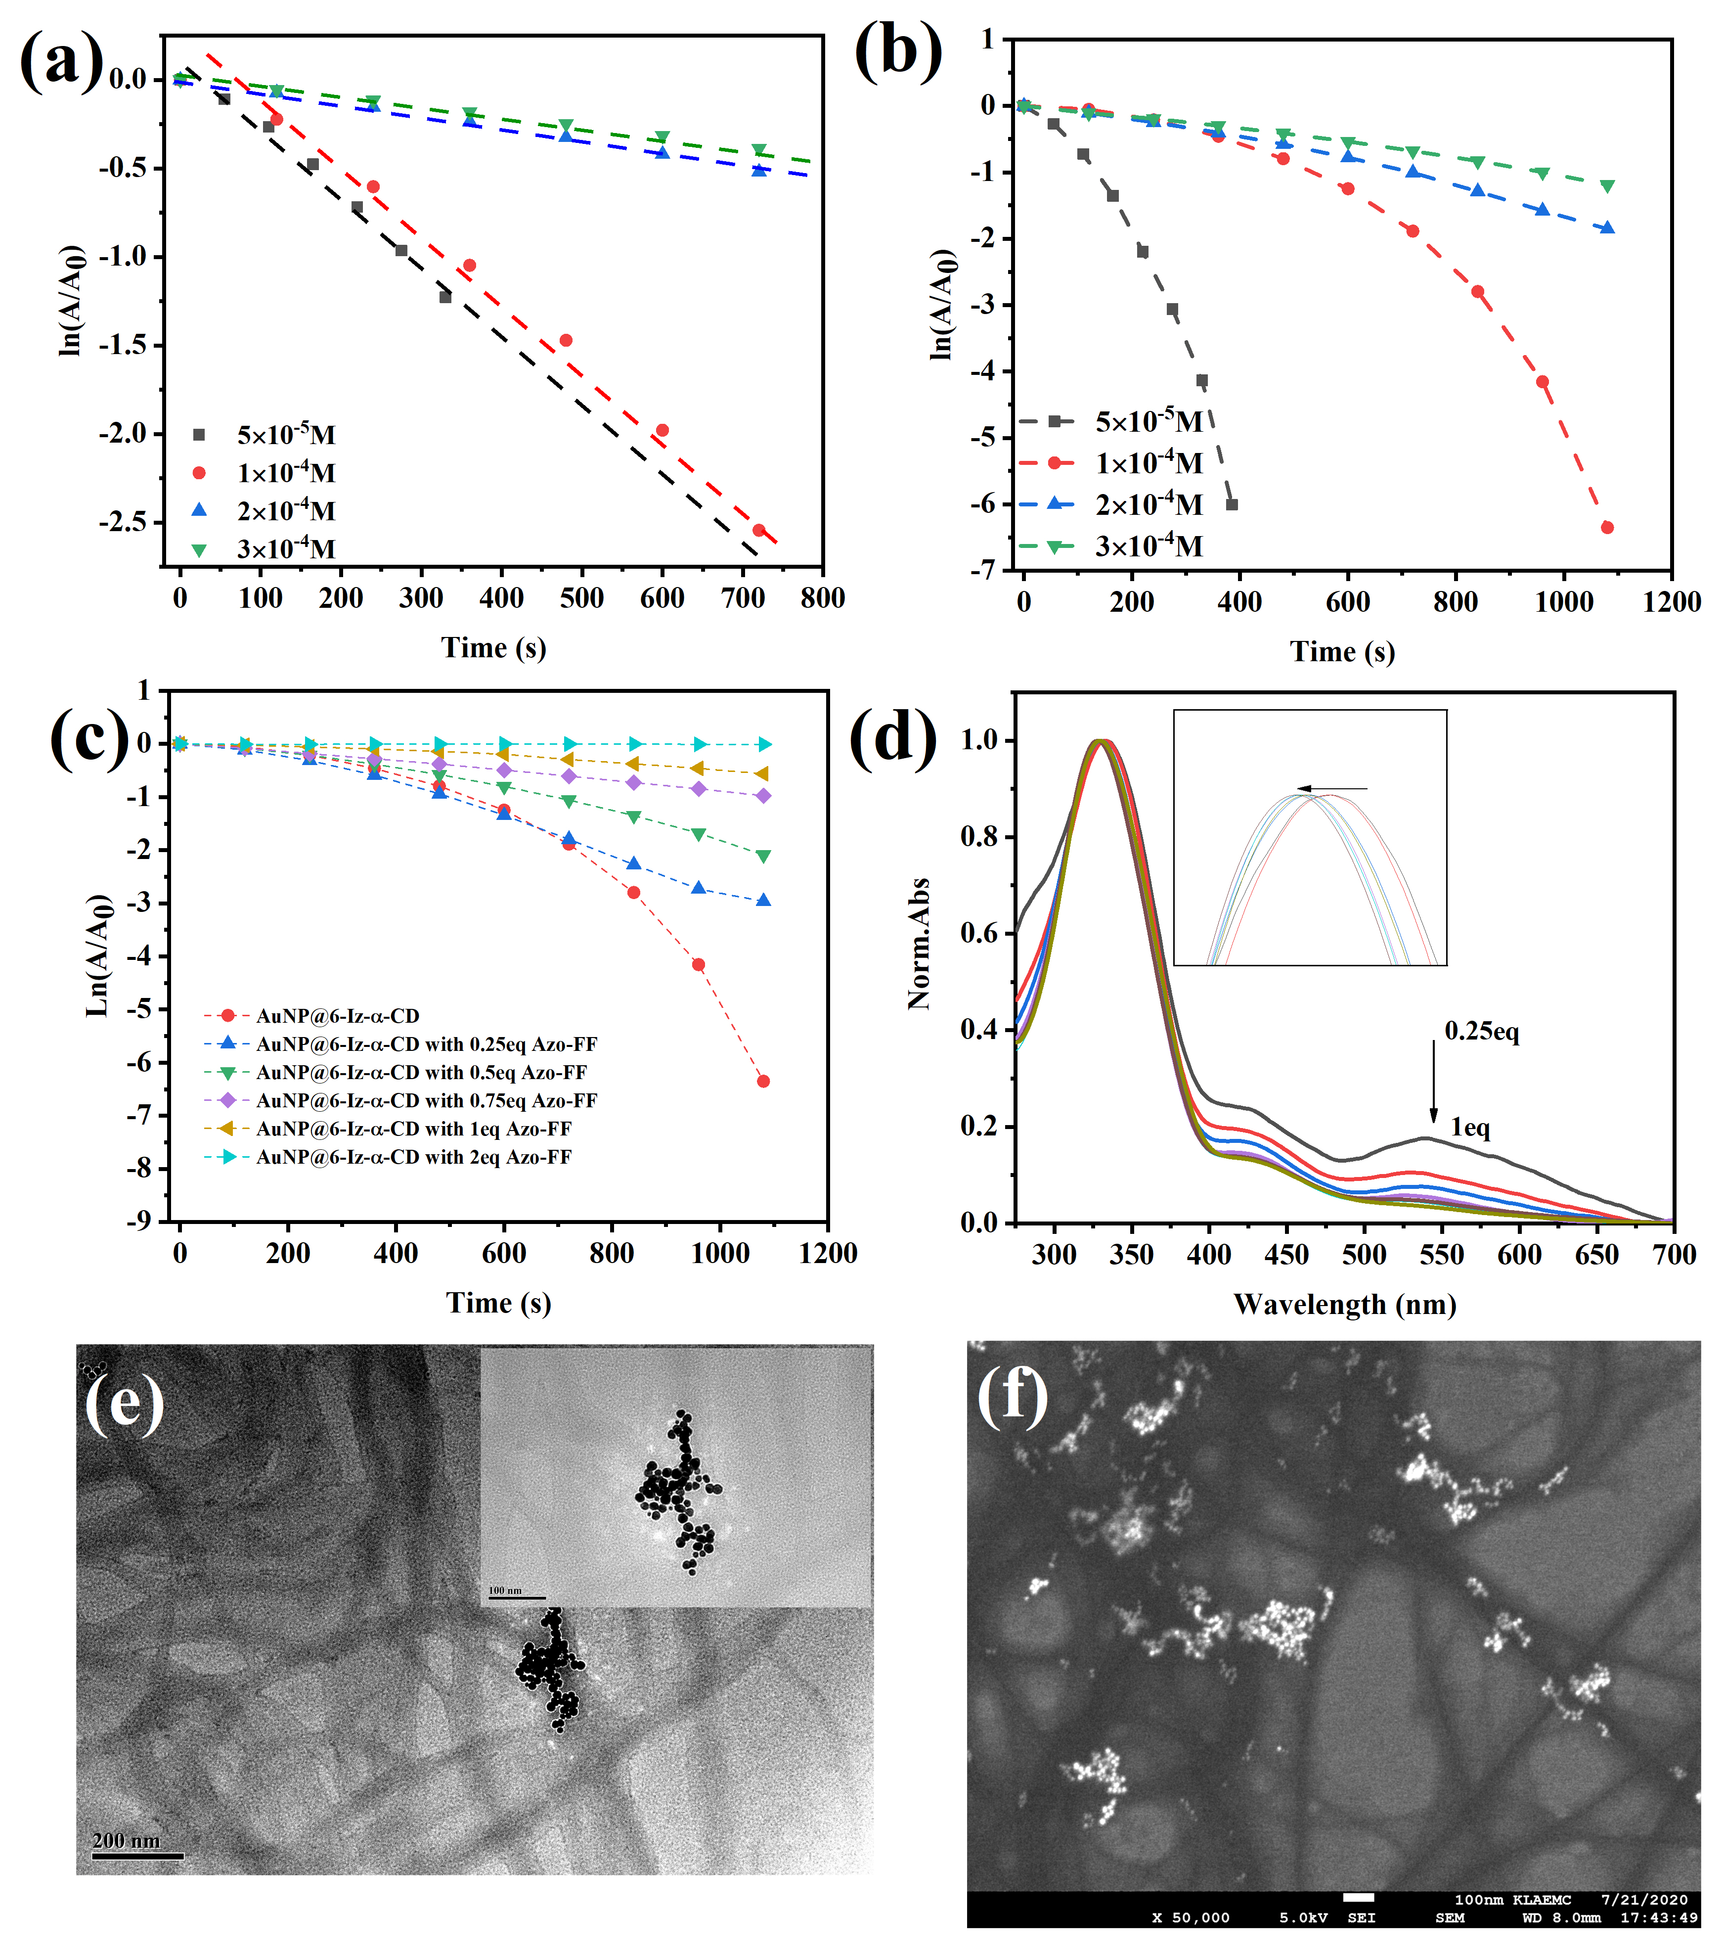
Figure 2. The reduction of 4-NP catalyzed by (a) AuNP (b) AuNP@6-Iz-α-CD([Au] = 7.96×10⁻⁴g/L, [6-Iz-α-CD] = 4×10⁻⁵M, [4-NP] = 5×10⁻⁵~3×10⁻⁴M) (c) AuNP@6-Iz-α-CD+Azo-FF([Azo-FF]=0~8×10⁻⁵M, [4-NP]=1×10⁻⁴M). (d) Changes of UV absorption of AuNP@6-Iz-α-CD with different equivalent Azo-FF (e) The morphology of the AuNP@6-Iz-α-CD+Azo-FF observed by TEM and (f) SEM.
To confirm this hypothesis, D-sodium gluconate was added into the AuNP and AuNP@6-Iz-α-CD respectively. It was found that D-sodium gluconate only inhibited the catalytic activity of the AuNP@6-Iz-α-CD (Figure S19). On the other hand, α-cyclodextrin was directly modified on nanoparticles (AuNP+α-CD) as a control group.^{[21]} (Figure S20-21) However, there was no significant difference in the catalytic oxidation of different chiral glucose. Hence, we inferred the following mechanism for chiral recognition and catalysis by the AuNP@6-Iz-α-CD (Figure 3e-f). The aldehyde group of D- or L-Glu contact with the AuNP through the cyclodextrin and undergoes AuNP-catalyzed oxidation to the corresponding sodium gluconate. However, the α-cyclodextrin cavity of 6-Iz-α-CD had a stronger affinity for D-Glu than for the corresponding enantiomers^{[22]} (Figures S22-25) and the imidazole group modified α-cyclodextrin makes the surface of AuNP positively charged. Hence, the higher bonding of the 6-Iz-α-CD cavity to the oxidation products of D-configuration glucose and the attraction of the positive charge on the surface of the assembly prevented the separation from the α-cyclodextrins cavity (Figure S26). Finally, the process of D-glucose catalyzed by supramolecular catalyst is terminated. However, the affinity between sodium L-gluconate and cyclodextrin cavity is negligible (Figure S27), so there is no effective host-guest interaction between them. L-Glu can squeeze it out of the cavity and continue the catalytic process. Based on the above characteristics, combined with the color reaction process of TMB, the chirality of monosaccharide can be easily and quickly judged by naked eyes. We subjected three pentoses (lyxose, ribose, and xylose) and a hexose (mannose) to the same catalytic process. For all the monosaccharide, the AuNP@6-Iz-α-CD can effectively distinguish enantiomers (Figure 4).
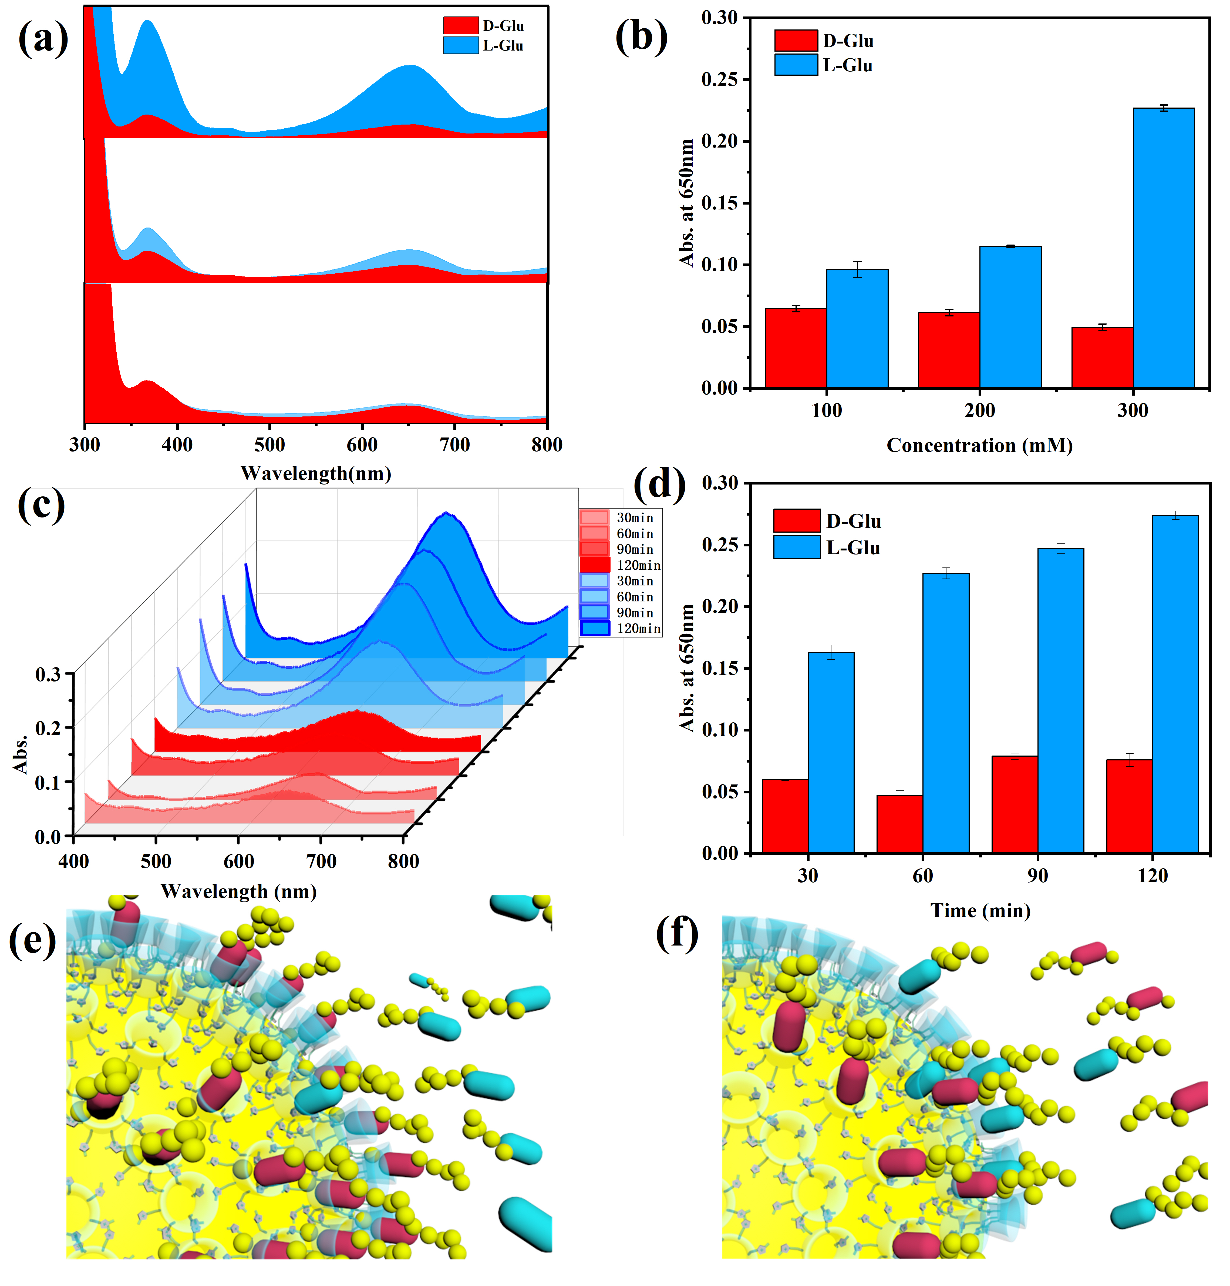
Figure 3. (a)(b) Catalysis of different concentration and different chiral substrates by AuNP@6-Iz-α-CD. (c)(d) Catalysis of different time and different chiral substrates by AuNP@6-Iz-α-CD. (e)(f) Simulation of the catalytic process of assemblies for different chiral monosaccharide.
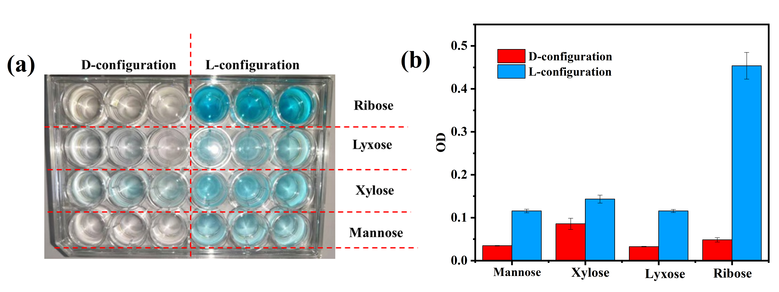
Figure 4. Rapid color recognition of different chiral monosaccharide by AuNP@6-Iz-α-CD.
In summary, we constructed supramolecular assemblies comprising 6-Iz-α-CD and AuNP. AuNP@6-Iz-α-CD assemblies acted as a catalytic centre. Intriguingly, the introduction of Azo-FF endowed the supramolecular assembly the ability of precise optical regulation of catalytic activity. Furthermore, AuNP@6-Iz-α-CD showed unprecedented special glucose oxidase activity and were able to distinguish between the enantiomers of monosaccharide substrates. The characteristic of AuNP@6-Iz-α-CD was used for the rapid colorimetric recognition of different chiral monosaccharides, which can quickly and effectively recognize the chirality of monosaccharides. With this work, we provide a convenient way to prepare intelligent response supramolecular catalyst, and the new application of cyclodextrin cavity was found by combining supramolecular assembly concept with catalysis, which laid a foundation for the development of supramolecular in catalysis field.
Acknowledgements
We thank NNSFC (21861132001, 21971127, 21772099) for financial support.
Keywords: supramolecular assembly• photo-controllable •catalysis• chirality recognition • cyclodextrin
[1] Z. Xu, S. Jia, W. Wang, Z. Yuan, B. Jan Ravoo, D-S. Guo, Nat. Chem. 2018, 11, 86-93;
[2] H-L. Sun, Y. Chen, X. Han, Y. Liu, Angew. Chem. Int. Ed. 2017, 56, 7062-7065.
[3] a) Q. Zhang, D-H. Qu, Q-C. Wang, H. Tian, Angew. Chem. Int. Ed. 2015, 54, 15789-15793; b) Q. Zhang, W-Z. Wang, J-J. Yu, D-H. Qu, H. Tian, Adv. Mater. 2017, 29, 160494.
[4] a) J. Huang, P. Su, B. Zhao, Y. Yang, Anal. Methods. 2015, 7, 2754-2761; b) X. Yao, H. Zheng, Y. Zhang, X. Ma, Y .Xiao, Y. Wang, Anal. Chem. 2016, 88, 4955-4964.
[5] a) D-S. Guo, T-X. Zhang, Y-X. Wang, Y. Liu, Chem. Commun. 2013 49, 6779-6781; b) V. U. Rein, J. Mater. Chem. 2006, 16, 2217-2225.
[6] J. Nanda， A. Biswasa，A. Banerjee，Soft Matter, 2013, 9, 4198-4208
[7] a) L. Chen, Y. Chen, H-G.Fu, Y.Liu, Adv. Sci. 2020, 7, 2000803; b) S.Yagai, A. Kitamura, Chem. Soc. Rev. 2008, 37, 1520-1529.
[8] Y-H. Wei, S-B. Han, J. Kim, S. Soh, B. A. Grzybowski, J. Am. Chem. Soc. 2010, 32, 11018-11020.
[9] a) J .Guo, H-Y. Zhang, Y. Zhou, Y. Liu, Chem. Commun. 2017, 53, 6089-6092 b) G. Liu, Y-M. Zhang, L. Zhang, C. Wang, Y. Liu, ACS. Appl. Mater. & Inter. 2017, 10, 12135-12140. c) R. Klajn, Chem. Soc. Rev., 2014, 43, 148-184.
[10] a)Y. Takashima, S. Hatanaka, M. Otsubo, M. Nakahata, T. Kakuta, A. Hashidzume, Nat. Commun. 2012, 3, 1270. b) W. Zhang, Y. Chen, J. Yu, X-J. Zhang, Y. Liu, Chem. Commun. 2016, 52, 14274-14277.
[11] Y-M. Zhang, N-Y. Zhang, K. Xiao, Q. Yu, Y. Liu, Angew. Chem. Int. Ed. 2018, 57, 8649-8653.
[12] W. Rechberger, A. Hohenau, A. Leitner, JR. Krenn, B. Lamprecht, FR. Aussenegg, Opt. Commun. 2003, 220, 137-141.
[13] H. Li, D-X. Chen, Y-L. Sun, YB. Zheng, L-L. Tan, PS. Weiss, J. Am. Chem. Soc. 2013, 135, 1570-1576.
[14] J -J. Li, Y. Chen, J. Yu, N. Cheng, Y. Liu, Adv. Mater. 2017, 29,1701905.
[15] a) H. Wei, E. Wang, Chem. Soc. Rev. 2013, 42, 6060-6093; b) W-J. Luo, C-F. Zhu, S. Su, D. Li, Y. He, Q. Huang, C-H. Fan, ACS Nano. 2010, 4, 7451–7458.
[16] P. Hu, Y. Chen, Y. Liu, Chem. Commun. 2015, 51, 10839-10842.
[17] KI. Assaf, A. Hennig, S. Peng, D-S. Guo, D. Gabel, WM. Nau, Chem. Commun. 2017, 53, 4616-4619.
[18] Y.Chen, Z. Wang , YW. Harn, S. Pan, Z. Li, S. Lin, Angew. Chem. Int. Ed. 2019, 58, 11910-11917.
[19] H. Yamaguchi, Y. Kobayashi, R. Kobayashi, Y. Takashima, A. Hashidzume, H. Akira, Nat .Commun. 2012, 3, 603.
[20] L. Gao, J. Zhuang, L. Nie, Nature Nanotech. 2007, 2, 577–583.
[21] T. Huang, Fei. Meng, L.M. Qi, J. Phys. Chem. C. 2009, 31, 13636–13642.
[22] W. Hirsch, T. Muller, R. Pizer, PJ. Ricatto, Can. J. Chem. 1995, 73, 12-15

Entry for the Table of Contents
The supramolecular assemblies constructed by polycationic α-cyclodextrin and gold nanoparticles based on the supramolecular strategy, which could not only realize the photo-controlled catalytic process through the host-guest interaction between the α-cyclodextrin and azobenzene-modified diphenylalanine, but also make full use of polycationic α-cyclodextrin cavity to recognize chiral monosaccharide and showed unprecedented selective catalytic performance.

